IN-COURSE ASSESSMENT (ICA) SPECIFICATION

Module Title:  Software for Digital Innovation | Module Leader: Steven Mead
 | Module Code: CIS4044-N
Assignment Title:  Historical Weather Data | Deadline Date:
 | Deadline Time:
Submission Method:

Online (Blackboard) þ
Middlesbrough Tower ¨

Online Submission Notes:

- Please carefully follow the instructions given in this Assignment Specification.

- When Extenuating Circumstances (e.g. extension) has been granted, a fully completed and signed Extenuating Circumstances form must be emailed to scedt-assessments@tees.ac.uk or submitted to the School Reception.

Central Assignments Office (Middlesbrough Tower M2.08) Notes:

- All work (including media) needs to be secured in a plastic envelope or a folder and clearly marked with the student name, number and module title.

- An Assignment Front Sheet should be fully completed before the work is submitted.

- When Extenuating Circumstances (e.g. extension) has been granted, a fully completed and signed Extenuating Circumstances form must be emailed to scedt-assessments@tees.ac.uk or submitted to the School Reception.

FULL DETAILS OF THE ASSIGNMENT ARE ATTACHED
INCLUDING MARKING & GRADING CRITERIA

Software for Digital Innovation (CIS4044-N)

Assignment Specification
Contents
Introduction 2
Assessment in Brief 3
Instructions for Historical Weather Data Application 4
Python Solution structure 5
Phase 1 – Python and SQLite3 Database Queries 5
Phase 2 – Basic Graphs using Matplotlib 6
Phase 3 - Data Retrieval and Storage 7
Open Meteo APIs 8
Further enhancements 9
Instructions for Report and Testing 10
Report 10
Testing 11
Example Blackbox testing entries 11
Deliverables 13
Marking Criteria 14

Introduction
This document describes the second element of assessment for the module. It is an individual in-course assignment (ICA).
This ICA assesses the following learning outcomes (from the Module Guide):
Personal and Transferable Skills Development
1. Apply high-level problem solving skills in a formal structured environment to meet a specification.
Research, Knowledge and Cognitive Skills
2. Demonstrate a systematic and critical understanding of programming concepts to solving a given problem.
3. Ability to read, interpret, understand and describe existing code solutions and identify errors.
4. Critically examine and evaluate relevant software tools and their appropriateness and limitations in a particular scenario.
5. Select and apply appropriate software libraries and tools to real world applications, and critically evaluate their effectiveness in the given scenario.
Professional Skills
6. Critically evaluate the security and other risk implications related to the utilisation of software libraries and tools to real world applications in the context of AI, Data Science or FinTech.

This component assesses Learning Outcomes 4, 5, and 6.

Assessment in Brief
You are to develop an application in Python to process historical weather data.
There are 3 main phases of the application which are described in more detail later, in summary the 3 phases are:
- Query and process data stored in the local Sqlite3 database. A partially populated database has been provided.
- Use Matplotlib to generate charts based on data taken from the Sqlite3 database provided.
- Retrieve data from a public web-API (Open-Meteo Weather Data) and update the data stored in the SQLite database.
You must provide evidence of non-functional testing through a combination of black-box testing. You will submit your final program(s) to Blackboard, along with a README outlining any installation or running instructions.
The final part of the assessment asks you to write a report that examines the relevant software tools used to complete the assessment, and for you to critically evaluate the security and other risk implications related to the utilisation of software libraries and tools to real world applications. Furthermore, you will also reflect upon how the fundamentals of programming concepts and higher-level data structures assisted in the development of the application.
See the marking criteria for a detailed breakdown of the marks available. Read the individual instruction sections carefully for additional guidance.

Instructions for Historical Weather Data Application
It is highly recommended that you use Visual Studio Code (VS Code) for the development of this assignment.

Python Solution structure
Ensure you provide details of each chart in a README file in the root directory of your source code.
Apply good programming practice throughout.
Ensure common functions are in their own Python module(s).
Extra marks will be given for appropriately demonstrating the use of classes to encapsulate data and behaviours.
Any user input should be validate for correct formats and data types.

Phase 1 – Python and SQLite3 Database Queries
You are provided with a partially populated database called ‘db/CIS4044-N-OPENMETEO-PARTIAL.db’. The database contains 3 tables (countries; cities; daily_weather_entries).
You can examine the tables using:
- DB Browser for SQLite (https://sqlitebrowser.org/dl/) and available on Apps Anywhere.
- SQLite3 Editor extension for VS Code (https://marketplace.visualstudio.com/items?itemName=yy0931.vscode-sqlite3-editor)
The database is limited such that:
- It only contains weather entries for the following years: 2020 to 2024.
- There are only 2 countries included.
- There are only 4 towns/cities included (2 per country).
- See the diagram below that describes the database tables, their structure and the relationships between the tables.
You’ve been provided with a Python file called ‘phase_1.py’ that includes several empty function definitions. The names of the functions indicate the results expected from Sqlite3 database queries. The queries increase in complexity. You are required to complete these functions with the required queries, printing the results to the console.
Warning! You must only use sqlite3 library is to be used for this phase. Failure to adhere to this will incur a marking penalty.

Phase 2 – Basic Graphs using Matplotlib
Develop Python functions to:
- Querying the data held in the sqlite3 database
- Generate basic plots using the library matplotlib, for example:
  - Bar chart to show the 7-day precipitation for a specific town/city
  - Bar chart for a specified period for a specified set of towns/cities
  - Bar chart that shows the average yearly precipitation by country
  - Grouped bar charts for displaying the min/max/mean temperature and precipitation values for selected cities or countries.
  - Multi-line chart to show the daily minimum and maximum temperature for a given month for a specific city.
  - Scatter plot chart for average temperature against average rainfall for town/city/country/all countries etc.
Some basic examples:
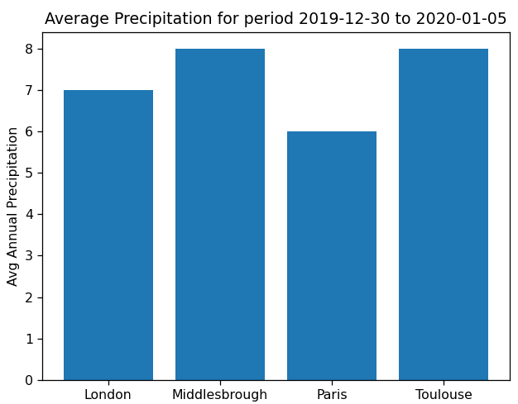 | 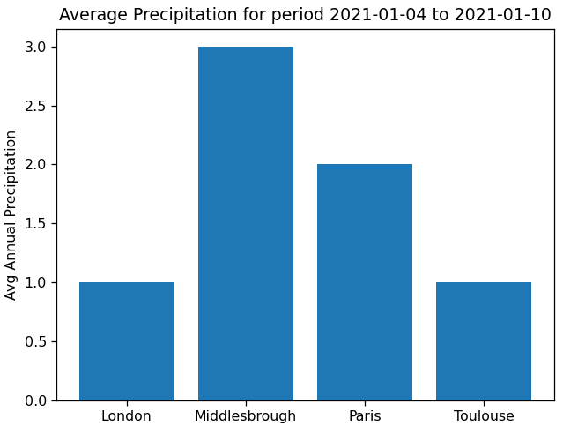
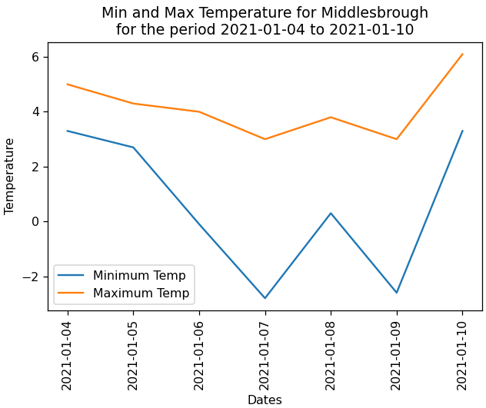 | 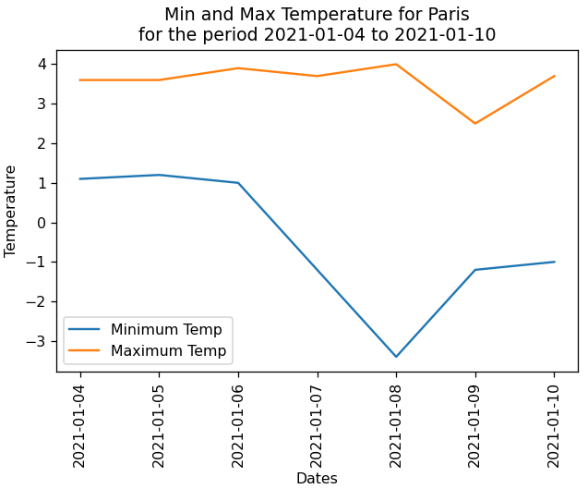

Warning! You must only use sqlite3 and matplotlib libraries are to be used for this phase. Failure to adhere to this will incur a marking penalty.

Phase 3 - Data Retrieval and Storage
https://open-meteo.com/ provides a free and publicly available weather-related web-services. You will access this service via Python and store a reduced set of data into a local sqlite3 database.
For a maximum of a PASS for this phase you may use OpenMeteo’s example for fetching data from their API.
For a Merit or Distinction grade for this phase you must write your own HTTP request handling code using the Python’s requests module.

Open Meteo APIs
End Point Base URL | Documentation URL | Notes
https://archive-api.open-meteo.com/v1/archive | https://open-meteo.com/en/docs/historical-weather-api | You will need to pass the required weather parameters appended to the end point.  Note: As stated in the API documentation, you must set the URL timezone parameter. For example, for any location in the UK the timezone parameter will be Europe/London (or GMT0) – other acceptable timezones can be found here (see TZ identifier column in table).
The data stored in the table ‘daily_weather_entries’ in the database provided was taken from this web-service.

Using Python retrieve data from the APIs from the table above. You will INSERT data into the sqlite3 database table(s) using the relevant data extracted from the JSON response.

You should update your user interface from phase 3 to allow the user to invoke this behaviour. However, you should endeavour to develop this such that it is not dependent on the menu.

Note: You will need to add additional towns/cities and increase the date range used for the queries.

Further enhancements
For students wanting to achieve higher marks, you are invited to extend the application further. Investigate the use of one of the following areas to further develop the application. For each area there are links to libraries that you’re recommended to use.
Marks will reflect the extent of the “added value” the use of the library brings to the overall application’s functionality.
Enhancement List
- CLI: Create a command line application that can take command-line arguments to determine how the application will behave whilst running. Python’s standard library includes the argparse module (https://docs.python.org/3/library/argparse.html)..
- Database abstraction/ORM: Use sqlalchemy to provide an abstracted way of querying and updating the database (https://www.sqlalchemy.org/) to perform database operations using an Object-Relational Mapper (ORM).
- Graphical User Interface (GUI): Research how to and develop a simple GUI using Tkinter (https://docs.python.org/3/library/tkinter.html)
- Simple Web Micro-Service: Research how to develop a simple web-service using FastAPI (https://fastapi.tiangolo.com/lo/) . You will need to demonstrate the web-service being used.
- Geocoding: Use city name to get the latitudinal and longitudinal data for a request – geocoder (https://pypi.org/project/geocoder/) is a suitable library for this task.

Notes:
- You’re not expected to attempt all these suggestions and you’re welcome to research and develop your own instead.
- The suggestions provided are of differing levels of effort and complexity and will be marked accordingly.

Instructions for Report and Testing

Report
You are to write a short report that:
- Critically examines the relevant software tools used for this assessment (including the portfolios) and evaluate their appropriateness and limitations.
- Critically evaluates the security and other risk implications related to the utilisation of software libraries and tools to real world applications in the context of Computer Science (CS), Data Science (DS), Artificial Intelligence (AI), Financial Technology (FinTech), or Digital Forensics (DF).
- Discuss how the fundamentals of programming and data structures provided by the standard library and environment assisted either directly or indirectly with your approach to and development of the application. Where applicable, provide short snippets of code as evidence and to aid the discussion.
This is an individual report, so what you submit must be your own work and not that created in collaboration with others. The document should be approximately 1000 words (the blackbox-testing is not included in the word count).
Software tools can refer to Integrated Development Environments (IDEs), other software packages, and Python packages/modules outside of the standard library.
The report requires independent research (particularly when investigating security and other risk implications). You should provide evidence of research through appropriate references. All references should be in the Harvard style following Cite Them Right Online.
Organise the report into suitable sections.
Read the marking criteria below and ensure that your final piece of work addresses all the criterion statements.

Testing
Provide evidence of non-functional testing for any code developed for this programming objective. You will develop test-cases before and during development to ensure reliability and accuracy.
Produce a black-box test plan containing the test cases appropriate to the functionality of your solution’s implementation. The expected format of your test cases is shown in the table below (colour scheme is not necessary but headings are):
Here is additional guidance on the definition of Blackbox testing: https://www.geeksforgeeks.org/software-engineering-black-box-testing/#what-is-black-box-testing.
An example is provided on the next page.

Example Blackbox testing entries
Id | Description | Steps | Expected | Actual | PASS/FAIL | Comment
1 | CALCULATION TEST  Ask the user to input 2 numbers and display the sum. | - Start the program  - Enter 1 as the first number and press enter.  - Enter 2 as the 2nd number and press enter. | The sum of the numbers 1 and 2 is 3. | The sum of the numbers 1 and 2 is 2. | FAIL | Checked the calculation for errors – the multiplication operator had been used instead of addition operator.
… | … | … | … | … | … | …
16 | USER INPUT VALIDATION  Ensure that an itinerary code is validated to exactly 6 characters only, but enter more characters than expected. | - Start the program  - Create a new itinerary.  - Enter J12345A as the itinerary code press enter. | Error message displayed to the user and user is asked to reenter the itinerary code. | Error message displayed to the user and user is asked to reenter the itinerary code. | PASS
17 | USER INPUT VALIDATION  Ensure that an itinerary code is validated to exactly 6 characters only, but enter fewer characters than expected. | - Start the program  - Create a new itinerary.  Enter J123A as the itinerary code press enter. | Error message displayed to the user and user is asked to reenter the itinerary code. | No error message | FAIL | Checked the validation algorithm. It only validated when itinerary codes were greater than 6. This has now been corrected.

Deliverables
- Source code: You must submit your Python code as a Visual Studio Code (VS Code) Workspace – An empty VS Code workspace is available on Blackboard.
- Report and Blackbox-testing: You will submit a single document for your report. The black-box testing documentation will be included as an appendix. Please submit the report in .xlsx (Excel format) or .odf (Open Data Format).

Marking Criteria
Criterion | Excellent 80+ | Very good  70-79 | Good  60-69 | Satisfactory  50-59 | Below Satisfactory 40-49 | Fail  0-39
Python Solution structure  [10%] | You have gone beyond the basic ICA requirements for this aspect. | Sensible scoping throughout, with little wasted code that fully adheres to PEP 8.  Code is excellently documented.  The solution throws no uncaught exceptions.  The code structure is split logically into separate files/modules to facilitate code re-use and allows for easier testing.  A README in the root directory that shows the author, how to run the program(s), provides details if the command line arguments, includes dependency information, and how to run the tests. | Sensible scoping throughout, with little wasted code, minor deviations from PEP 8.  An attempt has been made to document the code using Docstring.  Exception handling covers exceptions from imported packages, file verification, user input, and type casting.  The code structure is split logically into separate files/modules to facilitate code re-use.  The solution can be driven from a single starting point through an interactive shell menu.  A README in the root directory that shows the author, how to run the program(s), includes dependency information, and how to run the tests.  ‘requirements.txt file present to declare dependencies required. | Appropriate Python modules imported, variables created succinctly with few deviations from PEP 8.  Appropriate code comments are spread through the solution.  Validation and Exception handling is present but limited to file verification and type checking.  Some attempt has been made to move common functions into their own files/modules to facilitate code re-use, but code duplication remains.  The solution is split across several python modules that must be run individually. An attempt has been made to use a single starting point (interactive console menu).  A README in the root directory that shows the author, how to run the program(s), and includes dependency information. | Few Python modules imported, variables haphazardly created with many deviations from PEP 8.  Code comments are sparse.  Validation and Exception handling is very limited.  The solution is split across several python modules that must be run individually.  A README in the root directory that shows the author and how to run the program(s). | Code is not in a runnable state. Contains syntax errors, or unresolved runtime errors.  Few useful comments in code.  Validation and/or Exception handling is not present.  Some code present but taken directly from taught materials. Little in the way of further independent development.  Solution does not meet either programming objectives.  A README is not present.
Phase 1 – Database Queries  [15%] | You have gone beyond the basic ICA requirements for this aspect | Additionally, the identified queries for very good level have been successfully implemented. | Additionally, the identified queries for good level have been successfully implemented. | Identified queries for satisfactory level have been successfully implemented. | An incomplete or unsuccessful attempt to implement queries have been made, however it does demonstrate an understanding of SQL with Python. | Limited or no attempt.
Phase 2 - Database Queries and Basic Graphs using Matplotlib  [15%] | You have gone beyond the basic ICA requirements for this aspect. | An excellent set of visualisations identifying trends, patterns, comparisons multiple data points.  Data processing shows evidence of further statistical analysis through groupings and aggregations. | Code shows evidence of further data processing beyond the suggestions in the brief to identify trends, patterns, or draw further comparison between areas, dates etc.  You have gone beyond the basic bar and pie charts. | Basic processing of the data appropriate to the requirements of the basic charts.  Simple visualisations that show some attempt at customisation beyond the taught materials. An attempt has been made to show comparative data between age, outcome, or data across forces on the same plots. All plots are well labelled and appropriately titled. | Data can be processed using Python. Basic filtering on show. All instance variables (i.e. age range, gender, outcome etc.) are hard coded, with little customisation available to the end user.  Simple visualisations. Missing some labels and titles. Data parameters are fixed and cannot be altered. | Limited or no attempt.  Unable to visualise weather data.
Phase 3 - Data Retrieval and Storage  [30%] | You have gone beyond the basic ICA requirements for this aspect. | Handling of network failures are effectively handled.  Methods provided to manage data updates stored in the sqlite3 database have been considered and implemented accordingly. | Data can be retrieved by Python using an appropriate package.  Request parameters can be manipulated at runtime. The availability method within the API can be checked to return valid force and date choices.  All relevant database tables are correctly updated  You have designed and developed your own API requests rather than use OpenMeteos code and library. | Data can be retrieved by Python using an appropriate package.  Request parameters can be manipulated at runtime (choice of force and date).  OpenMeteos data fetching library used. | Data can be retrieved by Python using an appropriate package. Request is hardcoded.  Some success in updating the database. | Limited or no attempt.  Unable to retrieve data from the API end points,  Unable to demonstrate sqlite3 SQL queries.
Further enhancements  [10%] | Additional marks will be awarded to students extending the application further and/or experimenting with other related/relevant libraries.  A reasonable attempt must have been made to gain marks here. |  |  |  |  | Limited or no attempt.
Report and Testing  [20%] | You have gone beyond the basic ICA requirements for this aspect. | Report critically examines the relevant software tools used for this assessment and evaluates their appropriateness and limitations.  Report offers the reader and an very good treatment of the student’s understanding of the fundamentals of programming and knowledge of the standard data structures, and how they assisted in the development of the application.  Report is very well presented, absent of proofing errors, referencing is in expected format without error, word count +/- 10%.  An extensive black-box test plan that covers all aspects of the system. | Report describes the key software tools used for the assessment, evaluation includes facts and opinions of others with appropriate citations.  Report evaluates the security and other risk implications related to the utilisation of software libraries and tools to real world applications, evaluation includes facts and opinions of others with appropriate citations.  Report offers the reader and insightful discussion of the student’s understanding of the fundamentals of programming and knowledge of the standard data structures, and how they assisted in the development of the application.  Report is well presented, very few proofing mistakes, few deviations in referencing format, word count +/- 10%.  A comprehensive black-box test plan that covers most test cases including success, failure, and range. | Report describes the key software tools used for the assessment; evaluation is limited to self-experience.  Report addresses security and other risk implications related to the utilisation of software libraries and tools in real world applications. Evidence is mostly limited to hypothetical situations.  Report provides a reasonable reflection of the the fundamentals of programming and knowledge of the standard data structures assisted in the development of the application. However, it may be patchy and/or lacking in places.  Report is reasonably presented, minor proofing mistakes, minor deviations in referencing format, word count +/- 15%.  An acceptable black-box test plan showing individual test cases, but it is not sufficiently extensive. | Report describes some software tools used for the assessment. Limited evaluation present.  Report addresses some security and other risk implications related to the utilisation of software libraries and tools real world applications. Limited evaluation present.  Report minimally reflects upon the the fundamentals of programming and knowledge of the standard data structures assisted in the development of the application.  Report is reasonably presented, does contain some proofing mistakes, deviations in referencing format word count +/- 20%.  A limited black-box test plan is evident showing individual test cases, but it is poorly formatted and/or contains few tests. | Report does not examine the relevant software tools used for the assessment.  Report does not address the security and other risk implications related to the utilisation of software libraries and tools in real world applications.  Report does not reflect upon the the fundamentals of programming and knowledge of the standard data structures assisted in the development of the application.  Report is poorly formatted, with little meaningful content, few references of worth and not in expected format, word count +/- 30%.  Very superficial/extremely limited or No evidence of testing provided.

